Michele Speidel

8/14/2022

Module 2.2 Assignment

Building a Web Page Exercise, Part 1

CSD340-330H_2231_DD

Wev Development with HTML and CSS

Professor Sue Sampson

Test Results

Try 1 of 3

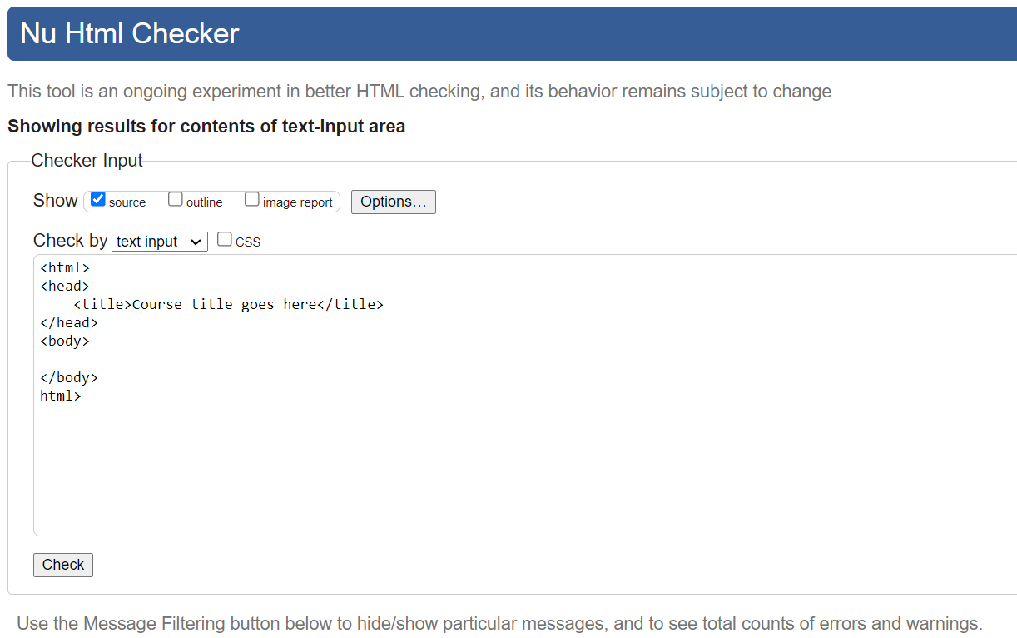

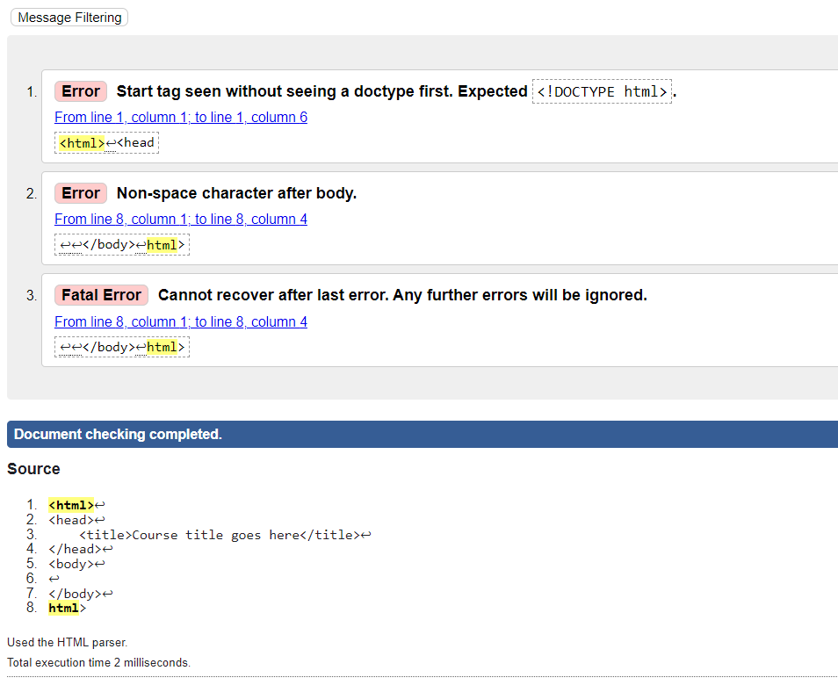

Try 2 of 3

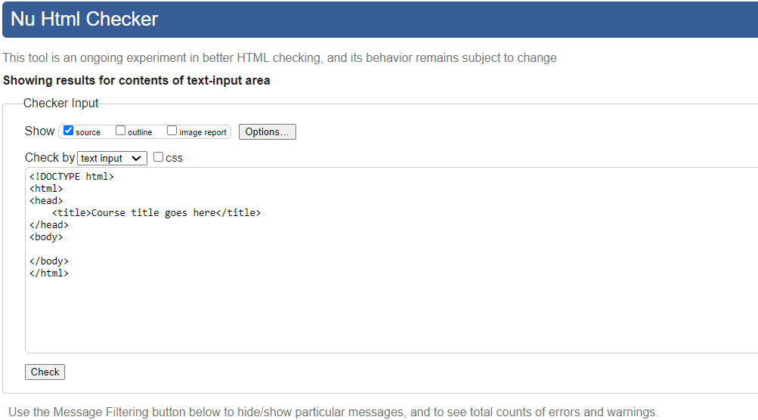

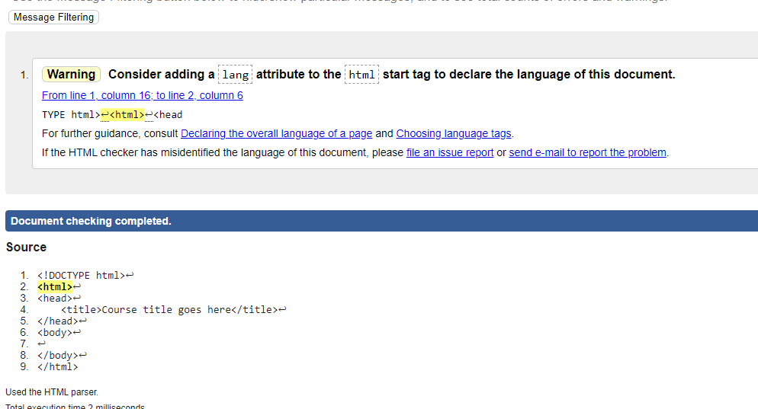

Try 3 of 3

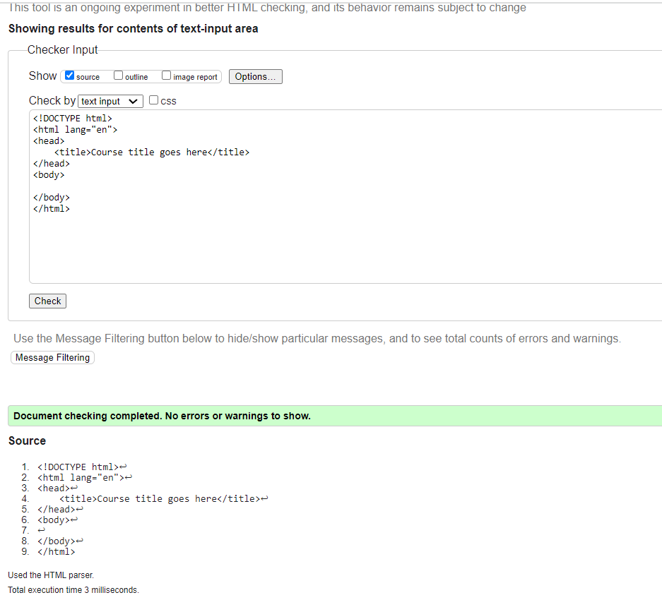

Results After Adding Header and Updating Title

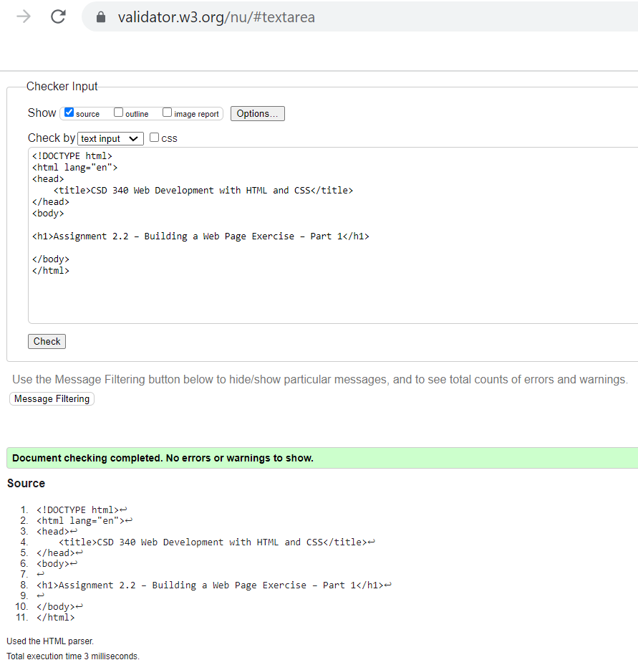

Web Page in Browser

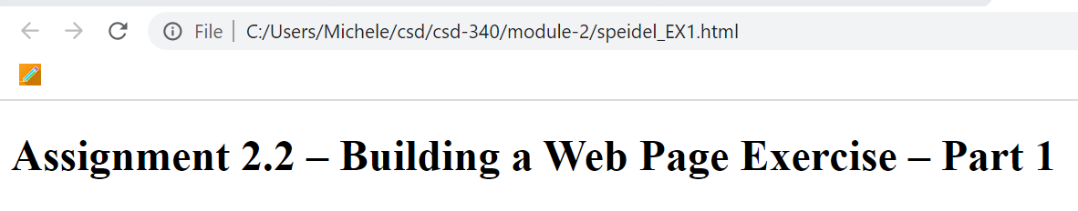

GitHub Link

<https://github.com/jamdmmsfreese/csd-340>